Name: G R Aakaash Slot: A
Reg No: 192412068 Course faculty: Sathish,K

EXP 8: STEERING ANGLE VARIATION IN MIMO BEAMFORMING USING MATLAB

OBJECTIVE 1: To analyze the steering angle of a MIMO beamforming system by directing the beam towards different target directions using MATLAB.
.

CODE: clc;
clear;
close all;
angle = [-60 -30 0 30 60]; % Steering Angles (degrees)
gain = ones(size(angle)); % Normalized Gain
figure
polarplot(deg2rad(angle), gain,'o-','LineWidth',2)
title('Steering Angle Variation in MIMO Beamforming')
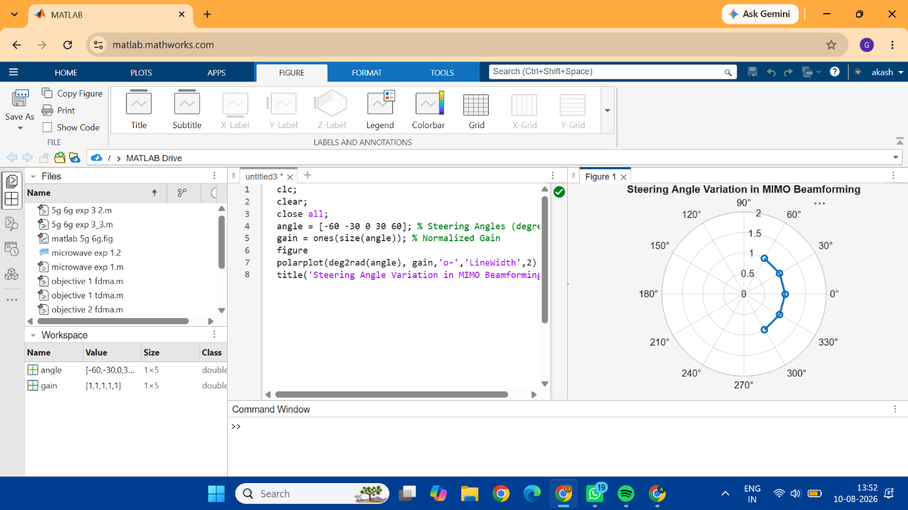

OBJECTIVE 2: To compare the array gain achieved for different steering angles in a MIMO beamforming system using MATLAB.

CODE: clc;
clear;
close all;
angle = [-60 -30 0 30 60]; % Steering Angles (degrees)
gain = [9 12 15 12 9]; % Array Gain (dB)
figure
bar(angle, gain)
grid on
xlabel('Steering Angle (Degrees)')
ylabel('Array Gain (dB)')
title('Array Gain for Different Steering Angles')
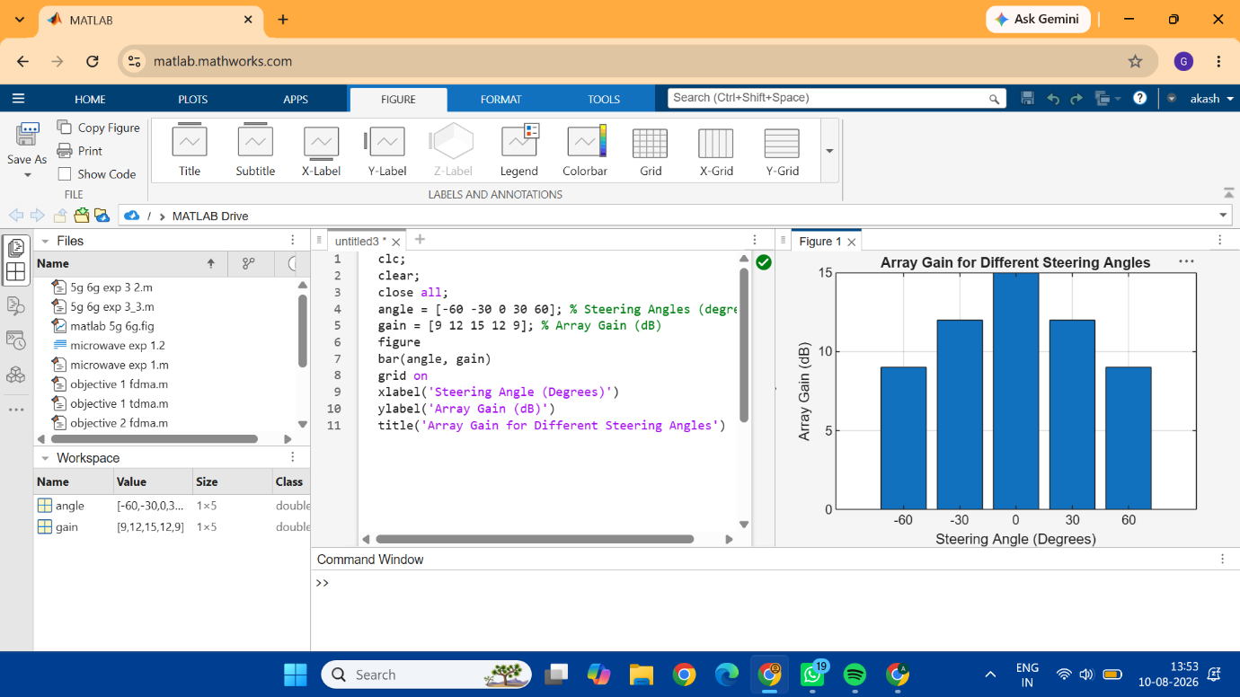

OBJECTIVE 3: To evaluate the beam direction error between the desired steering angle and the actual beam direction using MATLAB.

CODE: clc;
clear;
close all;
desired = [-60 -30 0 30 60]; % Desired Steering Angle (degrees)
actual = [-58 -32 1 29 62]; % Actual Beam Direction (degrees)
error = abs(desired - actual); % Beam Direction Error
figure
plot(desired, error, 'o-', 'LineWidth', 2)
grid on
xlabel('Desired Steering Angle (Degrees)')
ylabel('Beam Direction Error (Degrees)')
title('Beam Direction Error for Different Steering Angles')
